

GARAGE MANAGEMENT SYSTEM

**TEAM MEMBERS**

1. Prakash raj.M au713121205007 (TEAM LEAD)
2. Manojkumar.M au713121205005 (Member)
3. Vignesh kumar.P au71321205012(Member)

COLLEGE NAME : **SRI SAI RANGANATHAN ENGINEERING COLLEGE**

# PROJECT OVERVIEW

The Garage Management System is a web-based tool designed to manage and track all garage operations. The system aims to provide a centralized platform for garage owners to monitor and control their business activities, including employee management, inventory tracking, and customer service.

The system is built on the Salesforce platform, which provides a robust and secure infrastructure for managing and storing data. The Salesforce platform also offers a wide range of tools and features that can be used to customize and extend the system to meet the specific needs of the garage business.

One of the key features of the Garage Management System is its employee management module. This module allows garage owners to keep track of all their employees, including their contact information, work schedules, and job assignments. The system also provides tools for managing employee ``performance, such as tracking attendance and evaluating performance.

The Garage Management System also includes a customer service module, which allows garage owners to keep track of all their customers and their interactions with the garage.

The system provides tools for managing customer information, such as contact details and service history, as well as tools for scheduling appointments and tracking customer feedback.

# OBJECTIVES

**Business Goals**

-Optimize Garage Operations and Customer Experience

* Drive Revenue Growth and Efficient Resource Utilization
* Enable Data-Driven Decisions

**Specific Outcomes**

* Enhanced Data Accessibility
* Automated Scheduling and Service Tracking
* Inventory and Billing Automation
* Upsell and Cross-sell Recommendations
* Performance Analytics and Customer Retention.

# SALESFORCE KEY FEATURES AND CONCEPTS UTILIZED

**INTRODUCTION**

1.Creating Developer Account

2.Creating the Objects

3.Create the tabs

4.Create the lighting app

5.Create the Fields

6.Validation Rules

7.Duplicate Rules

8.Profiles

9.Role & Role Hierarchy

10.Users

11. Public Groups

12.Share Settings 1

3.Flows

14.Apex Trigger

15.Reports

16.DashBoard

# DETAILED STEPS TO SOLUTION DESIGN

**INTRODUCTION**

The Garage Management System is a comprehensive solution designed to optimize the usage of vehicles and trailers that carry inventories to stores. The system aims to streamline the management of vehicle records, track vehicles, and ensure efficient inventory transportation. The Garage Management System will be built on the Salesforce platform, leveraging its robust architecture and scalability. The system will consist of several components, including vehicle records, inventory management, workflow automation, and integration with other Salesforce modules. The implementation strategy will involve requirements gathering, design, development, testing, and deployment. The abstraction framework for the system will use an Integration Procedure to get input from a workflow, query the product model based on that input, and update products, attributes, and inventory levels. The Garage Management System will provide a flexible and scalable architecture formanaging and optimizing inventory transportation, ensuring efficient vehicle utilization, and automating business processes.

## TASK 1: Creating Developer Account:

### Creating a developer org in salesforce.

1. Go to https://developer.salesforce.com/signup
2. On the sign up form, enter the following details :
3. First name & Last name
4. Email
5. Role : Developer
6. Company : College Name
7. Country : India
8. Postal Code : pin code
9. Username : should be a combination of your name and company

This need not be an actual email id, you can give anything in the format : [username@organization.com](mailto:username@organization.com)

1. Click on sign me up after filling these.

**Account Activation**

1.Go to the inbox of the email that you used while signing up. Click on the verify account to activate your account. The email may take 5-10mins

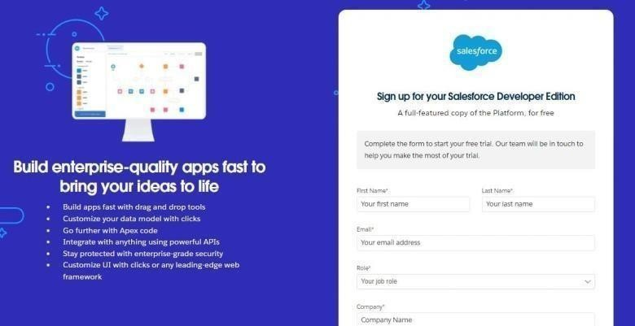

2.Click on Verify Account

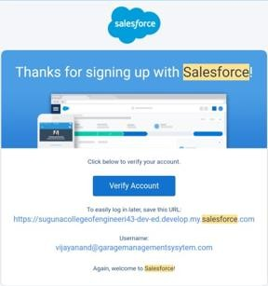

3.Give a password and answer a security question and click on change password.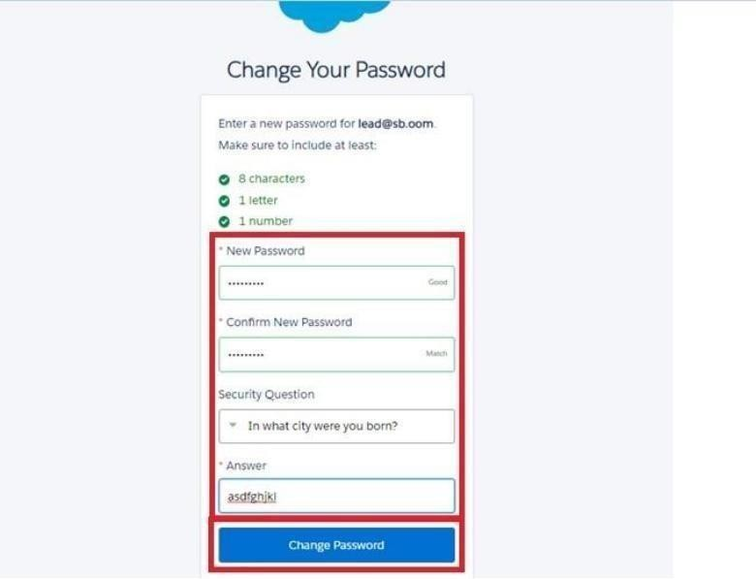

4.Then you will redirect to your salesforce setup page.

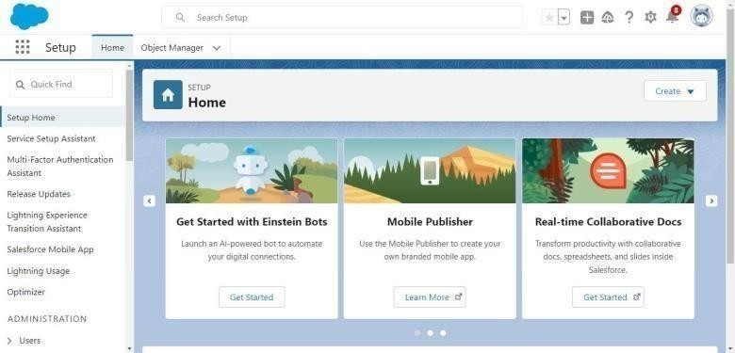

**TASK 2: CREATING THE OBJECTS**

* + 1. **Create Customer Details Object**
    2. **To create object**
       1. From the setup page >> Click on Object Manager >> Click on Create >> Click on Custom Object.

1. Enter the label name >> Customer Details
2. Plural label name >> Customer Details
3. Enter Record Name Label and Format
   * Record Name >> Customer Name
   * Data Type >> Text
     + 1. Click on Allow reports and Track Field History,
       2. 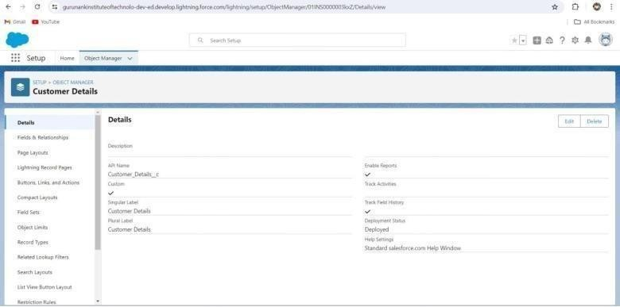Allow search >>



ii) Create Appointment ObjectTo create an object:

1. From the setup page >> Click on Object Manager >> Click on Create >> Click on Custom Object.

1. Enter the label name >> Appointment

2. Plural label name >> Appointments

3. Enter Record Name Label and Format

● Record Name >> Appointment Name

● Data Type >> Auto Number

* + Display Format >> app-{000}
  + Starting number >> 1

Click on Allow reports and Track Field History, 3. Allowsearc

>>Save

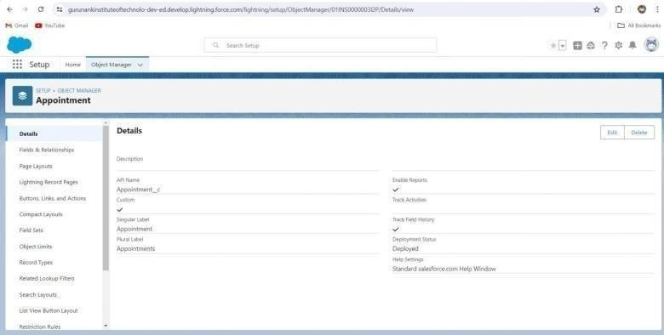

iv) Create Billing Details And Feedback ObjectTo create an object:

1. From the setup page >> Click on Object Manager >> Click on Create >> Click on Custom Object.

1. Enter the label name >> Billing details and feedback

2. Plural label name >> Billing details and feedback

3. Enter Record Name Label and Format

● Record Name >> Billing details and feedback Name

● Data Type >> Auto Number

● Display Format >> bill-{000}

● Starting number >> 1

2. Click on Allow reports and Track Field History,

>>Save

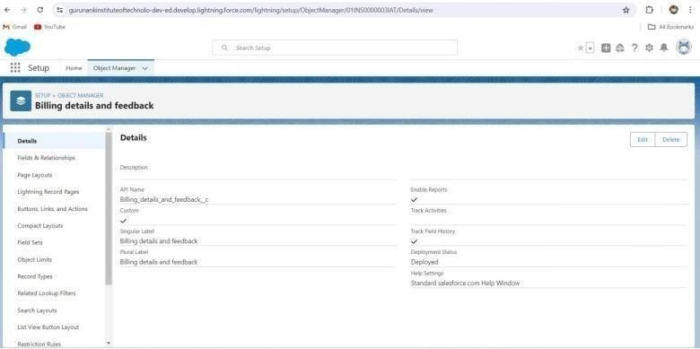

iv) Create Billing Details And Feedback ObjectTo create an object:

1. From the setup page >> Click on Object Manager >> Click on Create >> Click on Custom Object.

1. Enter the label name >> Billing details and feedback

2. Plural label name >> Billing details and feedback

3. Enter Record Name Label and Format

● Record Name >> Billing details and feedback Name

● Data Type >> Auto Number

● Display Format >> bill-{000}

● Starting number >> 1

2. Click on Allow reports and Track Field History,

3. Allow search >> Save.



## TASK 3: CREATE TABS

### Creating A Custom Tab

**To create a Tab:(Customer Details)**

1. Go to setup page >> type Tabs in Quick Find bar >> click on tabs >> New (under custom object tab)
2. Select Object (Customer Details) >> Select the tab style >> Next (Add to profiles page) keep it asdefault >> Next (Add to Custom App) uncheck the include tab .
3. Make sure that the Append tab to users' existing personal customizations is checked.
4. Click save .

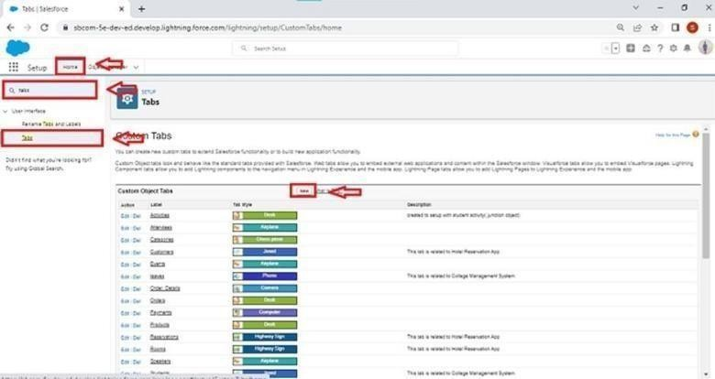

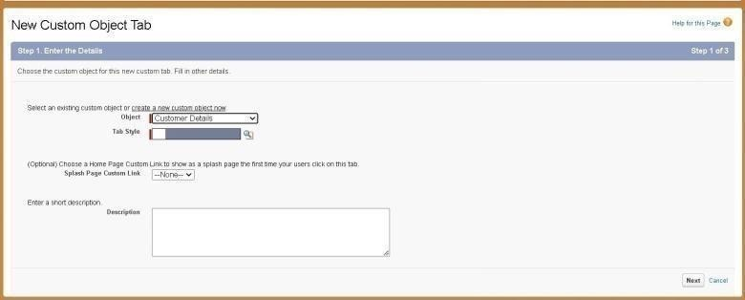

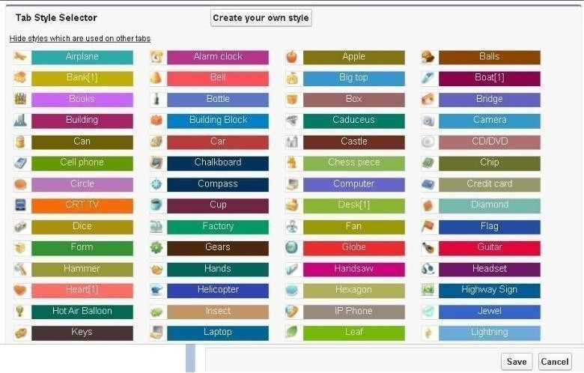

### To create a Tab:(Appointment)

1. Go to setup page >> type Tabs in Quick Find bar >> click on tabs >> New (under custom object tab)
2. Select Object (Appointment) >> Select the tab style >> Next (Add to profiles page) keep it as default >> Next (Add to Custom App) uncheck the include tab .
3. Make sure that the Append tab to users' existing personal customizations is checked.
4. Click save

### To create a Tab:(Service Records)

1. Go to setup page >> type Tabs in Quick Find bar >> click on tabs >> New (under custom object tab)
2. Select Object (Service Records) >> Select the tab style >> Next (Add to profiles page) keep it asdefault

>> Next (Add to Custom App) uncheck the include tab .

1. Make sure that the Append tab to users' existing personal customizations is checked.
2. Click save

### To create a Tab:(Billing details and feedback)

1. Go to setup page >> type Tabs in Quick Find bar >> click on tabs >> New (under custom object tab)
2. Select Object(Billing details and feedback) >> Select the tab style >> Next (Add to profiles page)keep it as default >> Next (Add to Custom App) uncheck the include tab .
3. Make sure that the Append tab to users' existing personal customizations is checked.
4. Click save

## TASK 4: CREATE THE LIGHTING APP

### To create a lightning app page:

1. Go to setup page >> search “app manager” in quick find >> select “app manager” >> click on Newlightning

App.

1. Fill the app name in app details as Garage Management Application >> Next >> (App option page)keep it as default >> Next >> (Utility Items) keep it as default >> Next.
2. To Add Navigation Items:
3. Select the items (Customer Details, Appointments, Service records, Billing details and feedback,Reports and Dashboards) from the search bar and move it using the arrow button >> Next.
4. To Add User Profiles:

Search profiles (System administrator) in the search bar >> click on the arrow button >> save & finish.

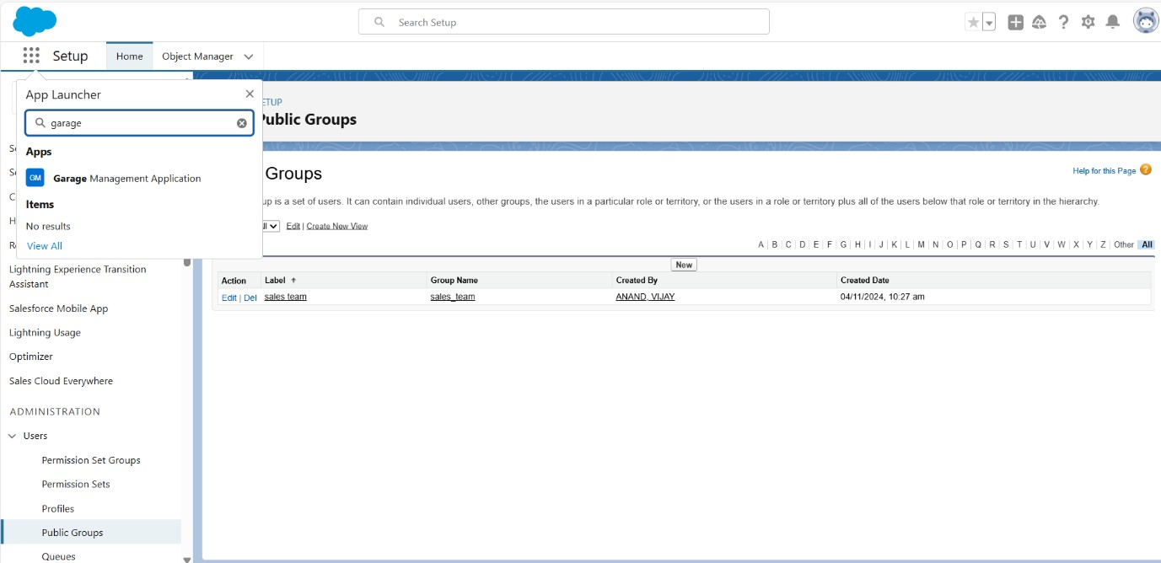

## TASK 5: CREATE THE FIELDS

### To create fields in an object:

* 1. Go to setup >> click on Object Manager >> type object name(Customer Details) in search bar >>click on the object.
  2. Now click on “Fields & Relationships” >> New

3.Select Data Type as a “Phone”

* 1. Click on next.
  2. Fill the Above as following:
     + Field Label: Phone number
     + Field Name : gets auto generated
     + Click on Next >> Next >> Save and new.

Note: Follow the above steps for the remaining field for the same object.

### To create another fields in an object:

* 1. Go to setup >> click on Object Manager >> type object name(Customer Details) in search bar >>click on the object.
  2. Now click on “Fields & Relationships” >> New
  3. Select Data type as a “Email” and Click on Next
  4. Fill the Above as following:
     + Field Label : Gmail● Field Name : gets auto generated ● Click on Next >> Next >> Save and new.

### Creation Of Lookup Fields

**Creation of Lookup Field on Appointment Object :**

1. Go to setup >> click on Object Manager >> type object name( Appointment ) in the search bar >>click on the object.
2. Now click on “Fields & Relationships” >> New
3. Select “Look-up relationship” as data type and click Next.
4. Select the related object “ Customer Details” and click next.
5. Next >> Next >> Save.

Note: Make sure you complete Activity 4 Before continuing.

### Creation of Lookup Field on Service records Object :

1. Go to setup >> click on Object Manager >> type object name( Service records ) in search bar >>click on the object.
2. Now click on “Fields & Relationships” >> New
3. Select “Look-up relationship” as data type and click Next.
4. Select the related object “ Appointment ” and click next.
5. Make it a required field so click on Required.
6. Scroll down for Lookup Filter and click on Show filter settings.
7. Now add the filter criteria.
8. Field : Appointment: Appointment Date >> Operator : less than >> select field >> Appointment:Created Date
9. Filter type should be Required.
10. Error Message : Value does not match the criteria.
11. Enable the filter by click on Active.
12. Next >> Next >> Save.

Creation of Lookup Field on Billing details and feedback Object :1. Go to setup >> click on ObjectManager

>> type object name ( Billing details and feedback ) in search bar >> click on the object.

1. Now click on “Fields & Relationships” >> New.
2. Select “Look-up relationship” as data type and click Next.
3. Select the related object “ Service records” and click next.
4. Next >> Next >> Save & new.

### Creation Of Checkbox Fields

**Creation of Checkbox Field on Appointment Object :**

1. Go to setup >> click on Object Manager >> type object name ( Appointment ) in search bar >>click on the object.
2. Now click on “Fields & Relationships” >> New.
3. Select “Check box” as data type and click Next.
4. Give the Field Label : Maintenance service
5. Field Name : is auto populated
6. Default value : unchecked
7. Click on next >> next >> save.

### Creation of Another Checkbox Field on Appointment Object :

1. Repeat the steps form 1 to 3.
2. Give the Field Label : Repairs
3. Field Name : is auto populated
4. Default value : unchecked
5. Click on next >> next >> save.
6. Follow the same and create another checkbox with given names
7. Give the Field Label : Replacement Parts
8. Field Name : is auto populated
9. Default value : unchecked
10. Click on next >> next >> save.

### Creation of Checkbox Field on Service records Object :

1. Go to setup >> click on Object Manager >> type object name( Service records ) in search bar >>click on the object.
2. Now click on “Fields & Relationships” >> New.
3. Select “Check box” as data type and click Next
4. Give the Field Label : Quality Check Status

Field Name : is auto populated

### Creation Of Date Fields

**Creation of Date Field on Appointment Object :**

1. Go to setup >> click on Object Manager >> type object name ( Appointment ) in the search bar >>click the object.
2. Now click on “Fields & Relationships” >> New.
3. Select “Date” as data type and click Next.
4. Give the Field Label : Appointment Date
5. Field Name : is auto populated
6. Make it as a Required field by click on the Required option.
7. Click on next >> next >> save.

### Creation Of Currency Fields

**Creation of Currency Field on Appointment Object :**

1. Go to setup >> click on Object Manager >> type object name( Appointment ) in the search bar >>click on the object.
2. Now click on “Fields & Relationships” >> New.
3. Select “Currency” as data type and click Next.
4. Give the Field Label : Service Amount
5. Field Name : is auto populated
6. Click on next
7. Give read only for all the profiles in field level security for profile.
8. Click on next > > save.

### Creation of Currency Field on Billing details and feedback Object :

1. Follow the same steps as mentioned above in Billing details and feedback Object.
2. Change the label name as mentioned.
3. Give the Field Label : Payment Paid.
4. Field Name : is auto populated.

### Creation Of Text Fields

1. Go to setup >> click on Object Manager >> type object name ( Appointment ) in the search bar >>click on the object.
2. Now click on “Fields & Relationships” >> New.
3. Select “Text” as data type and click Next.
4. Give the Field Label : Vehicle number plate
5. Field Name : is auto populated
6. Length : 10
7. Make field as Required and Unique.
8. Click on next >> next >> save.

### Creation of Text Fields in Billing details and feedback object :

1. Go to setup >> click on Object Manager >> type object name ( Billing details and feedback ) insearch bar >> click on the object.
2. Now click on “Fields & Relationships” >> New.
3. Select “text” as data type and click Next.
4. Give the Field Label : Rating for service
5. Field Name : is auto populated
6. Length : 1
7. Make field as Required and Unique.
8. Click on next >> next >> save.

### Creation Of Picklist Fields

**Creation of Picklist Fields in Service records object :**

1. Go to setup >> click on Object Manager >> type object name (Service records) in search bar >>click on the object.
2. Click on fields & relationship >> click on New.
3. Select Data type as “Picklist” and click Next.
4. Enter Field Label as “Service Status”, under values select “Enter values, with each value separatedby a new

line" and enter values as shown below.

1. The values are: Started, Completed
2. Click Next.
3. Next >> Next >> Save.

Creation of Picklist Fields in Billing details and feedback object :

1. Go to setup >> click on Object Manager >> type object name (Billing details and feedback) insearch bar >> click on the object.
2. Click on fields & relationship >> click on New.
3. Select Data type as “Picklist” and click Next.
4. Enter Field Label as “Payment Status”, under values select “Enter values, with each value separated by a new line" and enter values as shown below.
5. The values are: Pending, Completed.
6. Click Next.

### Creating Formula Field In Service Records Object

1. Go to setup >> click on Object Manager >> type object name (Service records) in search bar >>click on the object.
2. Click on fields & relationship >> click on New.
3. Select Data type as “Formula” and click Next.
4. Give Field Label and Field Name as “service date” and select formula return type as “Date” andclick next.
5. Insert field formula should be : CreatedDate
6. click “Check Syntax” .
7. Click next >> next >> Save.

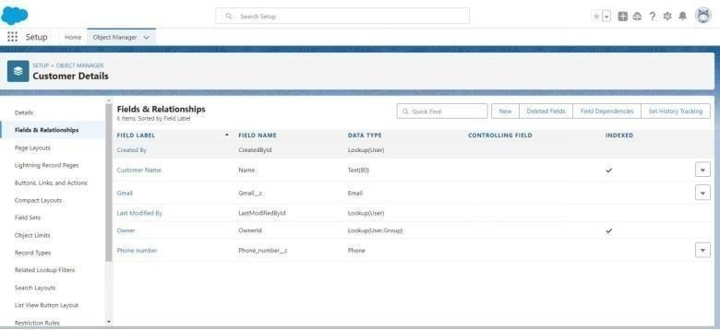

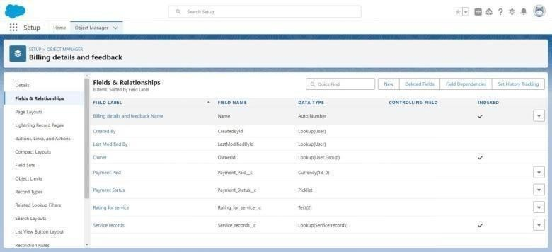

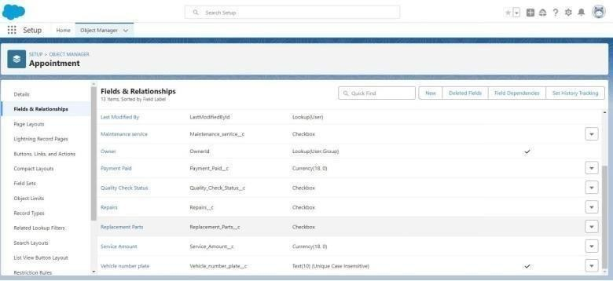

### To Create A Validation Rule To An Appointment Object

1. Go to the setup page >> click on object manager >> From drop down click edit for Appointmentobject.
2. Click on the validation rule >> click New.
3. Enter the Rule name as “ Vehicle ”.
4. Insert the Error Condition Formula as : -

NOT(REGEX( Vehicle_number_plate c , "[A-Z]{2}[0-9]{2}[A-Z]{2}[0-9]{4}"))

1. Enter the Error Message as “Please enter valid number ”, select the Error location as Field andselect the field as “Vehicle number plate”, and click Save.

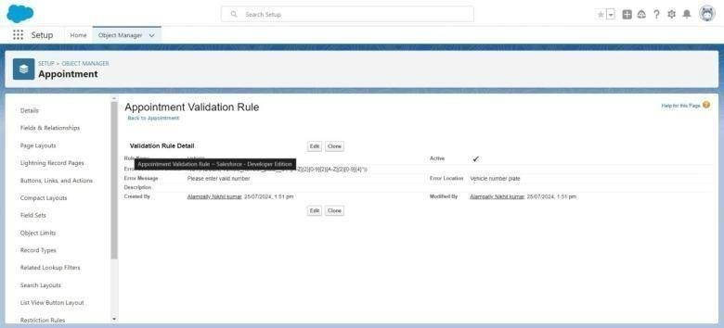

### To Create A Validation Rule To An Service Records Object

1. Go to the setup page >> click on object manager >> From drop down click edit for Service recordsobject.
2. Click on the validation rule >> click New.
3. Enter the Rule name as “ service_status_note ”.
4. Insert the Error Condition Formula as : -

NOT( ISPICKVAL( Service_Status c , "Completed"))

1. Enter the Error Message as “still it is pending”, select the Error location as Field and select the fieldas “Service status”, and click Save.

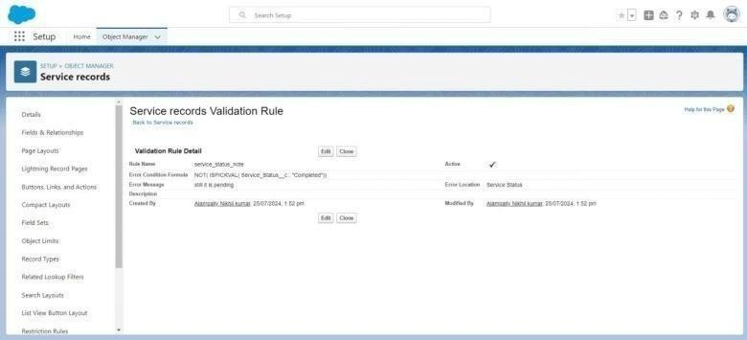To Create A Validation Rule To An Billing Details And Feedback Object

1. Go to the setup page >> click on object manager >> From drop down click edit for Billing detailsand feedback object.
2. Click on the validation rule >> click New.
3. Enter the Rule name as “ rating_should_be_less_than_5”.
4. Insert the Error Condition Formula as : - NOT( REGEX( Rating_for_service c , "[1-5]{1}"))
5. Enter the Error Message as “rating should be from 1 to 5”, select the Error location as Field andselect the field as “Rating for Service”, and click Save.

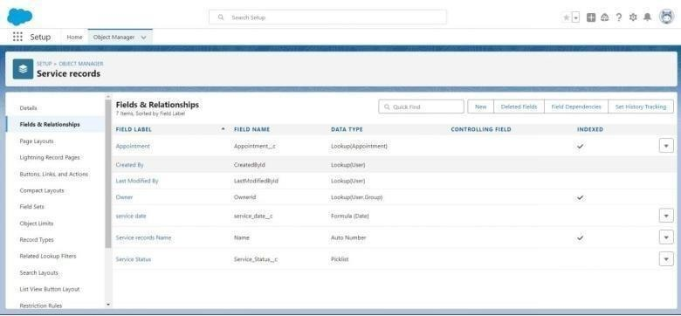

## TASK 7: DUPLICATE RULE

### To Create a Matching Rule To An Customer Details Object

1. Go to quick find box in setup and search for matching Rule.
2. Click on matching rule >> click on New Rule.
3. Select the object as Customer details and click Next.
4. Give the Rule name : Matching customer details
5. Unique name : is auto populated
6. Define the matching criteria as
7. Field Matching Method
   1. Gmail Exact
   2. Phone Number Exact
8. Click save.
9. After Saving Click on Activate.

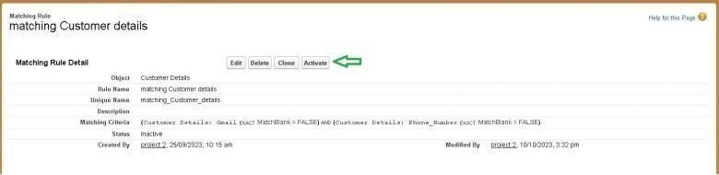

### To Create A Duplicate Rule To An Customer Details Object

1. Go to quick find box in setup and search for Duplicate rules.
2. Click on Duplicate rule >> click on New Rule >> select customer details object.
3. Give the Rule name as : Customer Scroll a little in Matching rule section
4. Select the matching rule : Matching customer details
5. And Click on save.

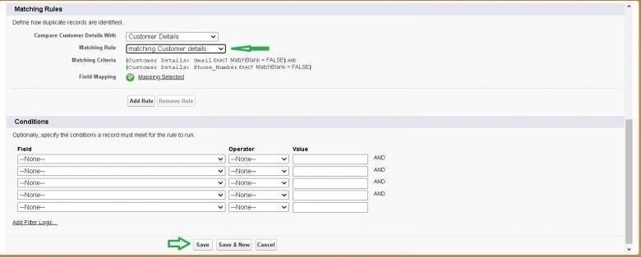

## TASK 8: CREATE PROFILES

### To Create A Duplicate Rule To An Customer Details Object

* 1. Go to quick find box in setup and search for Duplicate rules.
  2. Click on Duplicate rule >> click on New Rule >> select customer details object.
  3. Give the Rule name as : Customer Detail duplicate
  4. Scroll a little in Matching rule section
  5. Select the matching rule : Matching customer details
  6. And Click on save.
  7. After saving the Duplicate Rule, Click on Activate.

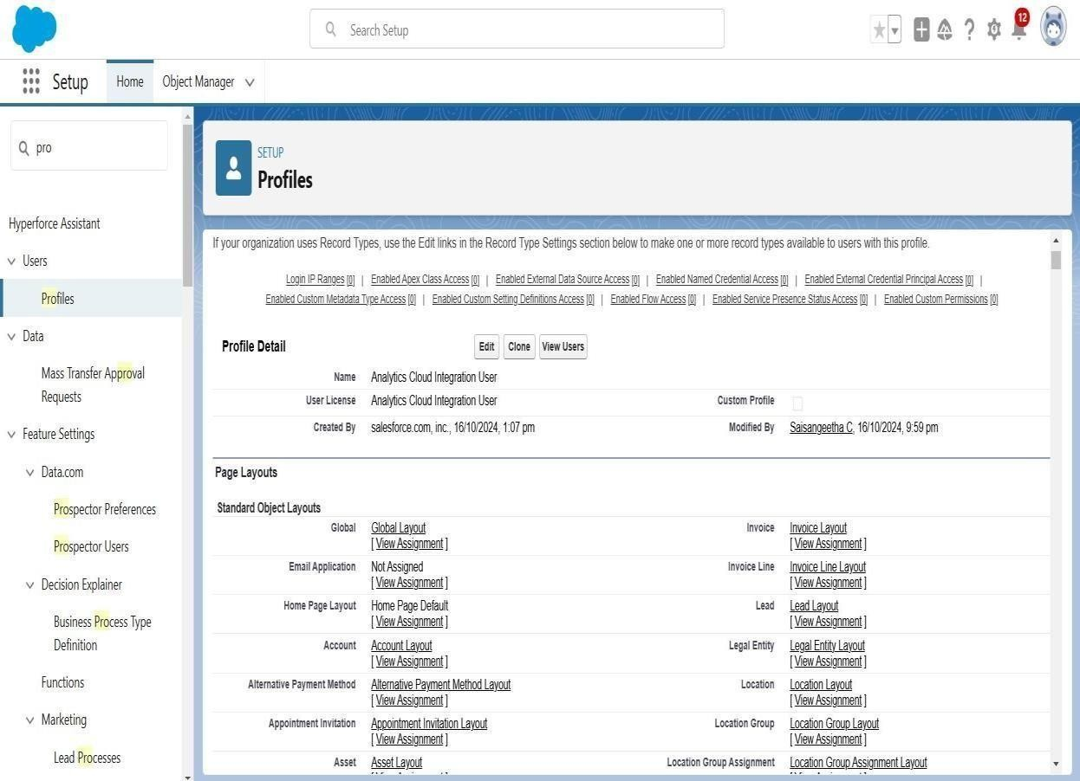

### Sales Person Profile

1. Go to setup >> type profiles in quick find box >> click on profiles >> clone the desired profile (Salesforce Platform User) >> enter profile name (sales person) >> Save.
2. While still on the profile page, then click Edit.
3. Select the Custom App settings as default for the Garage management.
4. Scroll down to Custom Object Permissions and Give access permissions for Appointments, Billingdetails and feedback , service records and customer details objects as mentioned in the below diagram.
5. And click save.

### 

### To Create A Validation Rule To An Service Records Object

1. Go to the setup page >> click on object manager >> From drop down click edit for Service recordsobject.
2. Click on the validation rule >> click New.
3. Enter the Rule name as “ service_status_note ”.
4. Insert the Error Condition Formula as : -

NOT( ISPICKVAL( Service_Status c , "Completed"))

1. Enter the Error Message as “still it is pending”, select the Error location as Field and select the fieldas “Service status”, and click Save.



### To Create A Validation Rule To An Billing Details And Feedback Object

1. Go to the setup page >> click on object manager >> From drop down click edit for Billing detailsand feedback object.
2. Click on the validation rule >> click New.
3. Enter the Rule name as “ rating_should_be_less_than_5”.
4. Insert the Error Condition Formula as : - NOT( REGEX( Rating_for_service c , "[1-
5. Enter the Error Message as “rating should be from 1 to 5”, select the Error location as Field andselect the field as “Rating for Service”, and click Save.



## TASK 7: DUPLICATE RULE

### To Create a Matching Rule To An Customer Details Object

1. Go to quick find box in setup and search for matching Rule.
2. Click on matching rule >> click on New Rule.
3. Select the object as Customer details and click Next.
4. Give the Rule name : Matching customer details
5. Unique name : is auto populated
6. Define the matching criteria as
7. Field Matching Method
   1. Gmail Exact
   2. Phone Number Exact
8. Click save.
9. After Saving Click on Activate.

### To Create A Duplicate Rule To An Customer Details Object

1. Go to quick find box in setup and search for Duplicate rules.
2. Click on Duplicate rule >> click on New Rule >> select customer details object.
3. Give the Rule name as : Customer Detail duplicate
4. Scroll a little in Matching rule section
5. Select the matching rule : Matching customer details
6. And Click on save.

After saving the Duplicate Rule, Click on Activate



## TASK 8: CREATE PROFILES

### To Create A Duplicate Rule To An Customer Details Object

* 1. Go to quick find box in setup and search for Duplicate rules.
  2. Click on Duplicate rule >> click on New Rule >> select customer details object.
  3. Give the Rule name as : Customer Detail duplicate
  4. Scroll a little in Matching rule section
  5. Select the matching rule : Matching customer details
  6. And Click on save.
  7. After saving the Duplicate Rule, Click on Activate.



### Sales Person Profile

1. Go to setup >> type profiles in quick find box >> click on profiles >> clone the desired profile (Salesforce Platform User) >> enter profile name (sales person) >> Save.
2. While still on the profile page, then click Edit.
3. Select the Custom App settings as default for the Garage management.
4. Scroll down to Custom Object Permissions and Give access permissions for Appointments, Billingdetails and feedback , service records and customer details objects as mentioned in the below diagram.
5. And click save.

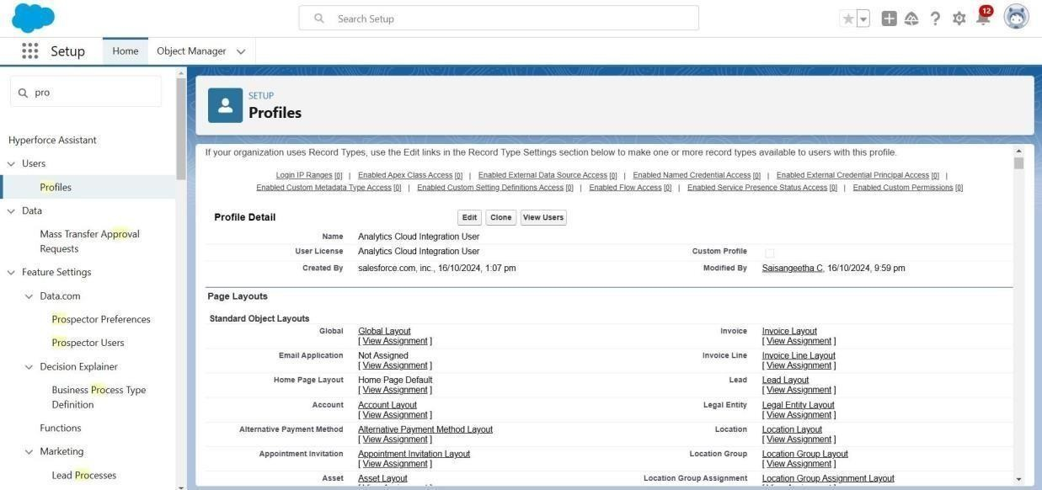

## TASK 9: Role & Role Hierarchy

### Creating Manager Role:

1. Go to quick find >> Search for Roles >> click on set up roles.
2. Click on Expand All and click on add role under whom this role works.
3. Give Label as “Manager” and Role name gets auto populated.Then click on Save.

### Creating Another Roles

**Creating another two roles under manager**

1. Go to quick find >> Search for Roles >> click on set up roles.
2. Click plus on CEO role, and click add role under manager.
3. Give Label as “sales person” and Role name gets auto populated.Then

click on Save.

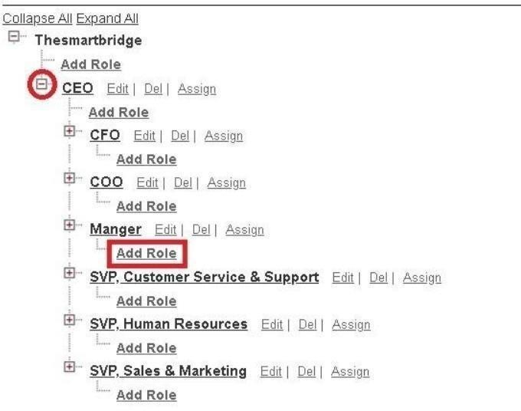



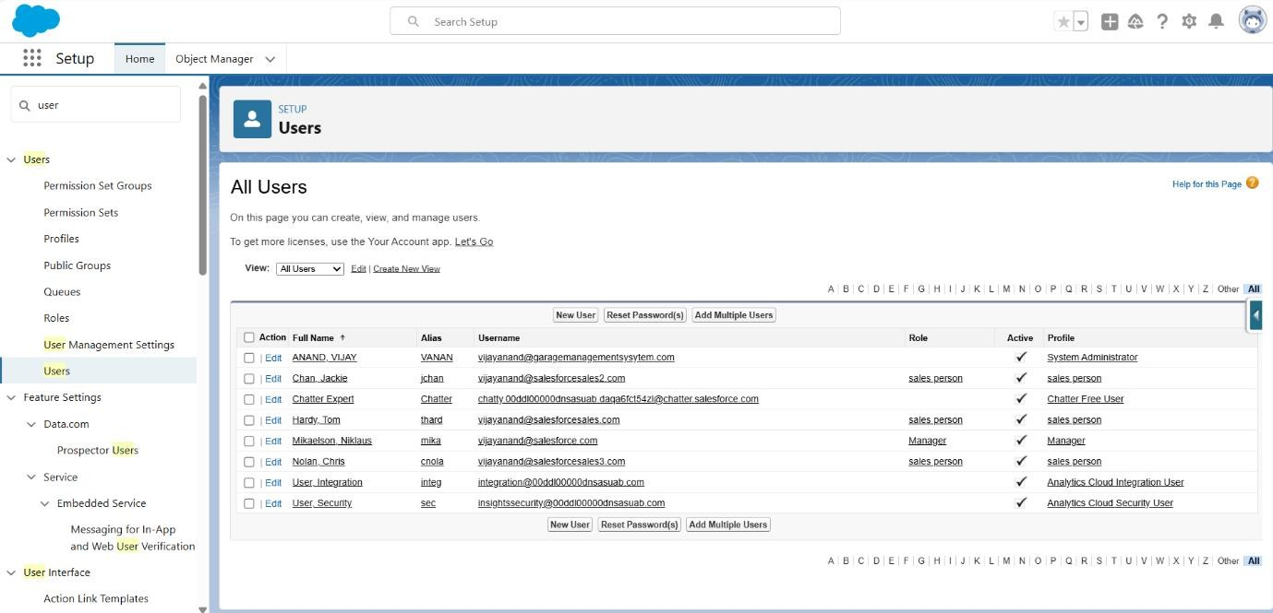

## TASK 11: PUBLIC GROUPS

### Creating New Public Group

1. Go to setup >> type users in quick find box >> select public groups >> click New.
2. Give the Label as “sales team”.
3. Group name is auto populated.
4. Search for Roles.
5. In Available Members select Sales person and click on add it will be moved to selected member.
6. Click on save.

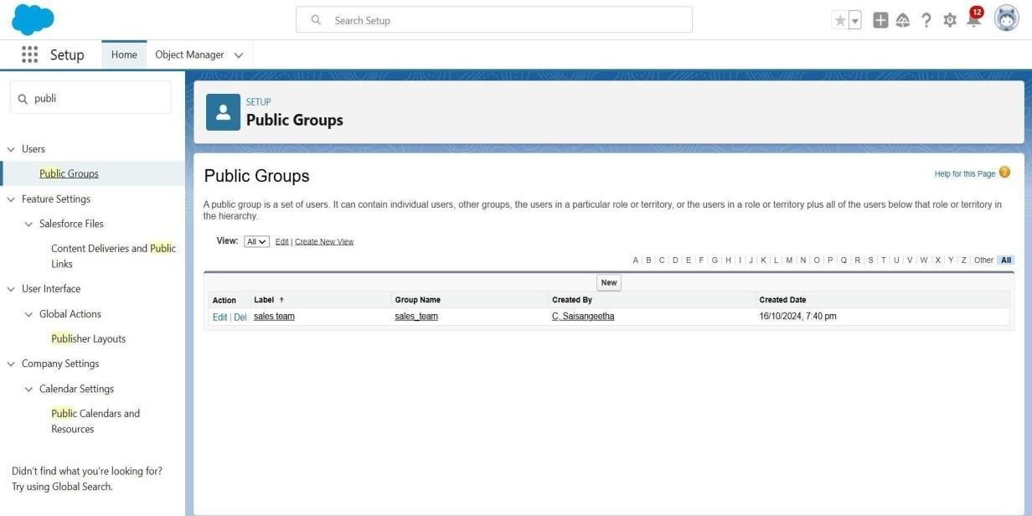

## TASK 12: SHARE SETTING

### Creating Sharing Settings

1. Go to setup >> type users in quick find box >> select Sharing Settings >> click Edit.
2. Change the OWD setting of the Service records Object to private as shown in fig.
3. Click on save and refresh.
4. Scroll down a bit, Click new on Service records sharing Rules.
5. Give the Label name as “ Sharing setting”
6. Rule name is auto populated.
7. In step 3 : Select which records to be shared, members of “ Roles ” >> “ Sales person”
8. In step 4: share with, select “ Roles ” >> “ Manager ”
9. In step 5 : Change the access level to “ Read / write ”.
10. 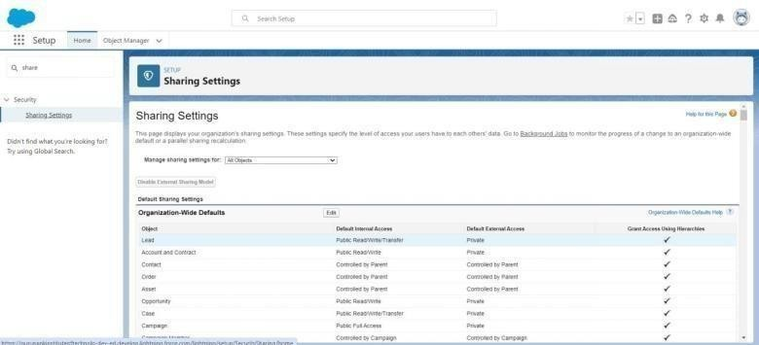Click on save.

## TASK 13: FLOWS

### Create A Flow

1. Go to setup >> type Flow in quick find box >> Click on the Flow and Select theNew Flow.
2. Select the Record-triggered flow and Click on Create.
3. Select the Object as “Billing details and feedback” in the Drop down list.
4. Select the Trigger Flow when: “A record is Created or Updated”.5. Select the Optimize the flow for:

“Actions and Related Records” and Click on Done.

1. Under the Record-triggered Flow Click on “+” Symbol and In the Drop down List select the
2. Give the Label Name : Amount Update
3. Api name : is auto populated

Set a filter condition : All Conditions are met(AND)

1. Field : Payment_Status c
2. Operator : Equals
3. Value : Completed
4. And Set Field Values for the Billing details and feedback Record
5. Field : Payment_Paid c
6. Value : {!$Record.Service_records r.Appointment r.Service_Amount c}
7. Click On Done.
8. Before creating another Element. Create a New Resource form Toolbox form top left.
9. Click on the New Resource, And select Variable.
10. Select the resource type as text template.
11. Enter the API name as “ alert”.
12. Change the view as Rich Text ? View to Plain Text.
13. In body field paste the syntax that given below.

Dear {!$Record.Service_records r.Appointment r.Customer_Name r.Name},

I hope this message finds you well. I wanted to take a moment to express my sincere gratitude for your recent payment for the services provided by our garage management team. Your prompt payment is greatly appreciated, and it helps us continue to provide top-notch services to you and all our valued customers.

Amount paid : {!$Record.Payment_Paid c} Thank you for Coming

1. Click done.
2. Now Click on Add Element , select Action.
3. Their action bar will be opened in that search for “ send email ” and click on it.
4. Give the label name as “ Email Alert”
5. API name will be auto populated.
6. Enable the body in set input values for the selected action.
7. Select the text template that created , Body : {!alert}
8. Include recipient address list select the email form the record.
9. RecipientAddressList:

{!$Record.Service_records r.Appointment r.Customer_Name r.Gmail c}

1. Include subject as “ Thank You for Your Payment - Garage Management”.
2. Click done.
3. Click on save. Give the Flow label , Flow Api name will be auto populated. 35. And click save, andclick on activate.

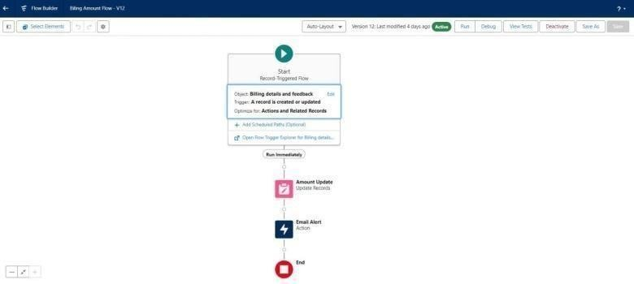

# TESTING AND VALIDATION:

## TASK 14: APEX TRIGGER

### Apex Handler

Use Case : This use case works for Amount Distribution for each Service the customer selected forthere Vehicle.

1. Login to the respective trailhead account and navigate to the gear icon in the top right corner.
2. Click on the Developer console. Now you will see a new console window.
3. In the toolbar, you can see FILE. Click on it and navigate to new and create New apex class.
4. Name the class as “AmountDistributionHandler ”.

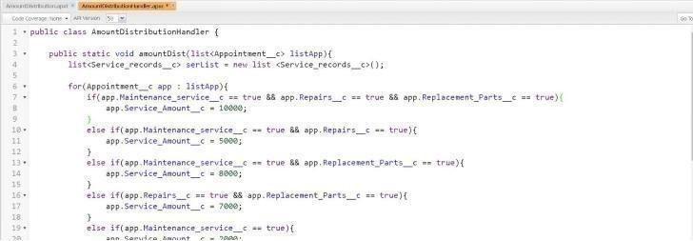

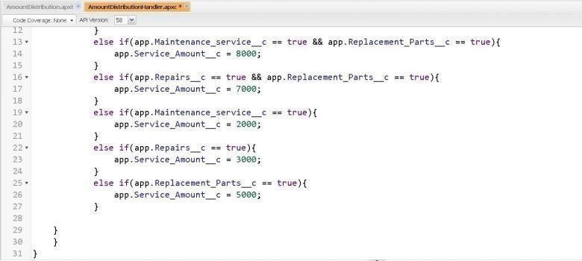

### Trigger Handler:

**How to create a new trigger :**

1. While still in the trailhead account, navigate to the gear icon in the top right corner.
2. Click on developer console and you will be navigated to a new console window.
3. Click on File menu in the tool bar, and click on new? Trigger.
4. Enter the trigger name and the object to be triggered.
5. Name : AmountDistribution
6. 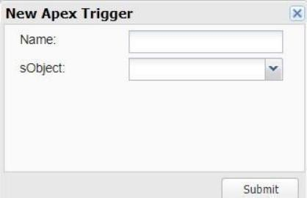sObject : Appointment c
7. Syntax For creating trigger :
8. The syntax for creating trigger is :
9. Trigger [trigger name] on [object name]( Before/After event)

In this project , trigger is called whenever the particular records sum exceed the threshold i.e minimum

business requirement value. Then the code in the trigger will get executed.

* 1. Handler for the Appointment Object

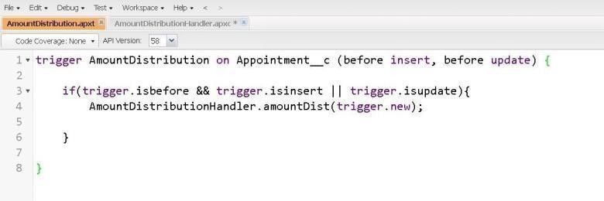

# KEY SCENARIOS ADDRESSED BY SALESFORCE IN THE IMPLEMENTATION PROJECT

## TASK 15: REPORTS

### Create A Report Folder

1. Click on the app launcher and search for reports.
2. Click on the report tab, click on new folder.
3. Give the Folder label as “Garage Management Folder”, Folder unique name will be auto populated.
4. Click save.

### Sharing A Report Folder

1. Go to the app >> click on the reports tab.
2. Click on the All folder , click on the Drop down arrow for Garage Management folder, and Click onshare.
3. Select the share with as “roles”, in name field search for “manager”, give “view” as access for thatrole.
4. Then click share, and click on Done.

### Create Report Type

1. Go to setup >> type users in quick find box >> select Report Type >> click on Continue.
2. Click on new custom report type.
3. Select the Primary object as “ Customer details” .
4. Give the Report type Label as “ Service information ”
5. Report type Name is autopopulated.
6. Keep the Description as same.
7. Select Store in Category as “ other Reports ”
8. Select the deployment status as “ Depolyed ”, click on Next.
9. now , Click on Related object box.
10. Click on Select Object, choose Appointment Object as shown in fig.
11. Again Click to relate another object.
12. And select the related object as “ service records”.
13. Repeat the process and select the related object as “ Billing details and feedback”.
14. And click on save.

### Create Report

Note : Before creating report, create latest “10” records in every object. Try to fill every fieldin each record for better experience.

1. Go to the app >> click on the reports tab
2. Click New Report.
3. Select the Category as other reports, search for Service Information, select that report, click on it.And click on start report.
4. Their outline pane is opened already, select the fields that mentioned below in column section.
   1. Customer name
   2. Appointment Date
   3. Service Status
   4. Payment paid
   5. Remove the unnecessary fields.
   6. Select the fields that mentioned below in GROUP ROWS section.
      1. Rating for Service
   7. Select the fields that mentioned below in GROUP ROWS section.
      1. Payment Status

Click on Add Chart , Select the Line Chart.

* 1. Click on save, Give the report Name :

New Service information Report

* 1. Report unique Name is auto populated.
  2. Select the folder the created and Click on save.

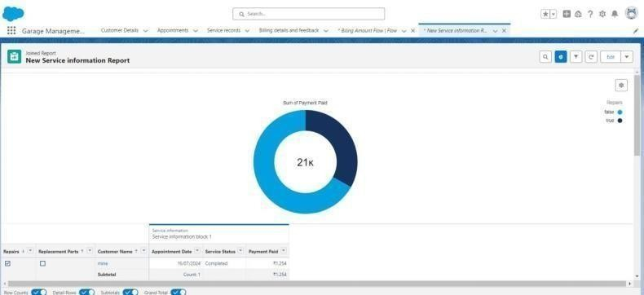

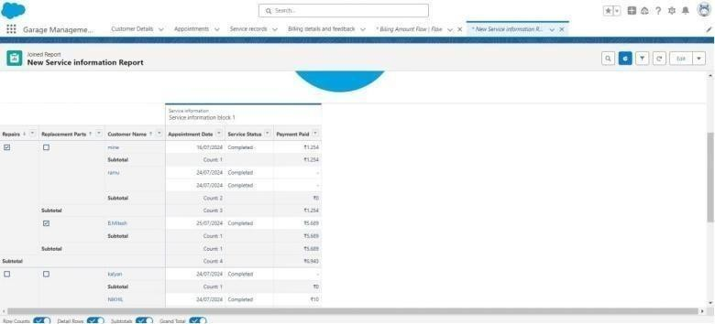

## TASK 16: DASHBOARD

### Create Dashboard Folder

1. Click on the app launcher and search for dashboard.
2. Click on dashboard tab.
3. Click new folder, give the folder label as “ Service Rating dashboard”.
4. Folder unique name will be auto populated.
5. Click save.
6. Follow the same steps, form milestone 15, and activity 2, and provide the sharing settings for thefolder that just created.

### Create Dashboard

1. Go to the app >> click on the Dashboards tabs.
2. Give a Name and select the folder that created, and click on create.
3. Select add component.
4. Select a Report and click on select.
5. Select the Line Chart. Change the theme.
6. Click Add then click on Save and then click on Done.
7. Preview is shown below.
8. After that Click on Subcribe on top right.
9. Set the Frequency as “ weekly ”.
10. Set a day as monday.
11. 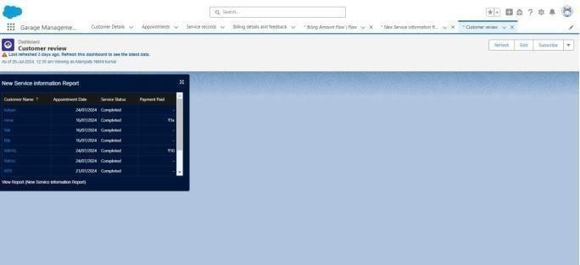And Click on save.

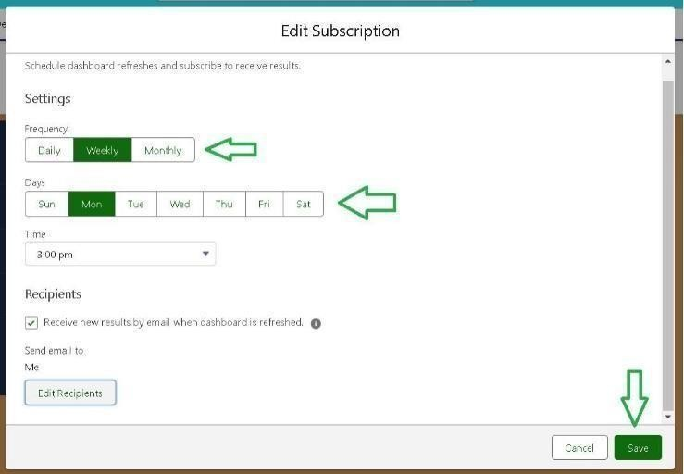

**CONCLUSION:**

The Garage Management System using Salesforce streamlines operations, enhances customer service, and boosts efficiency. With features like automation, real-time analytics, and scalability, it ensures smooth management of services, inventory, and billing while supporting business growth and customer satisfaction.

` `

THANK YOU…